explicit wait and wait method

First screenshot explains, how to take screenshot in Selenium. There is a standard 2 lines of code for this.

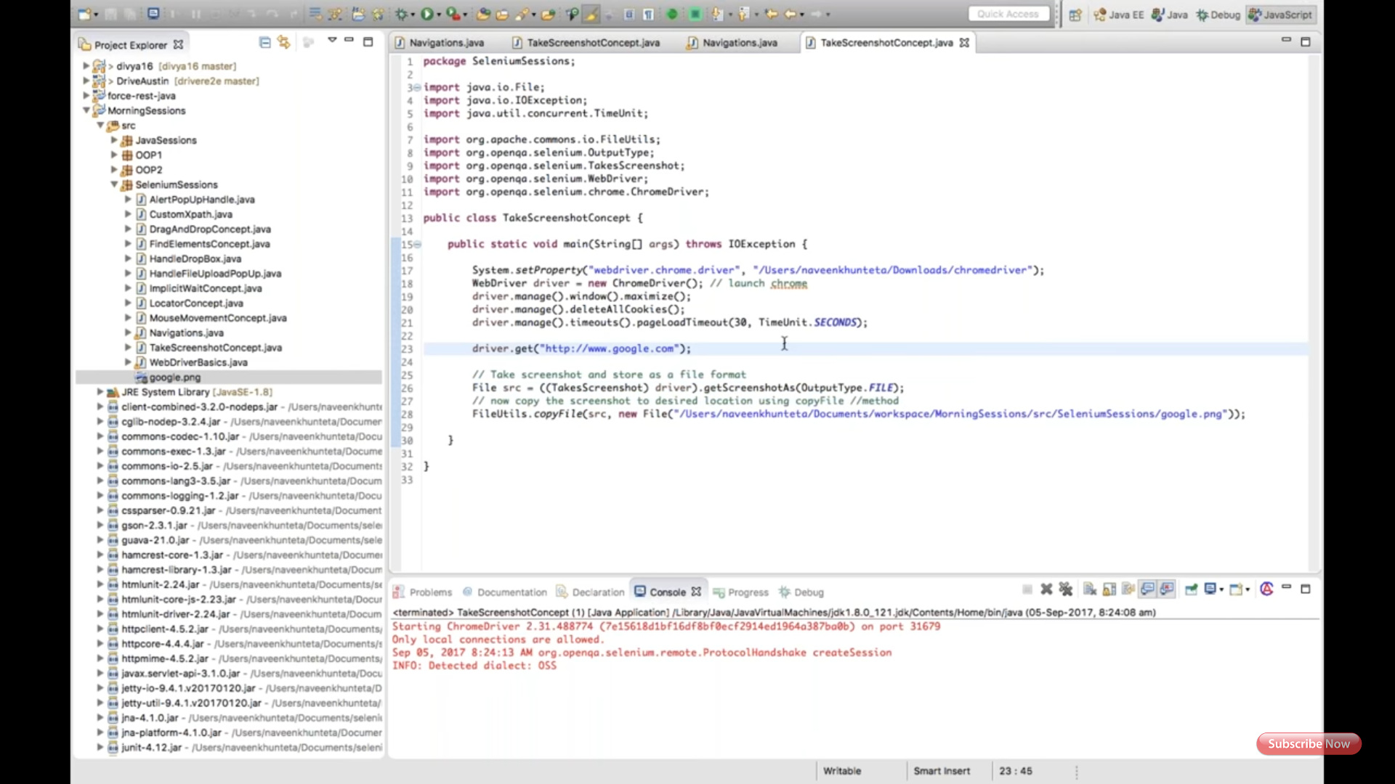

Second screenshot explains has implicit, pageload, and explicit wait. It has generic method for explicit wait.

